Python Lesson 2: Turtle drawing
We can draw simple graphics in Python by programming a turtle.
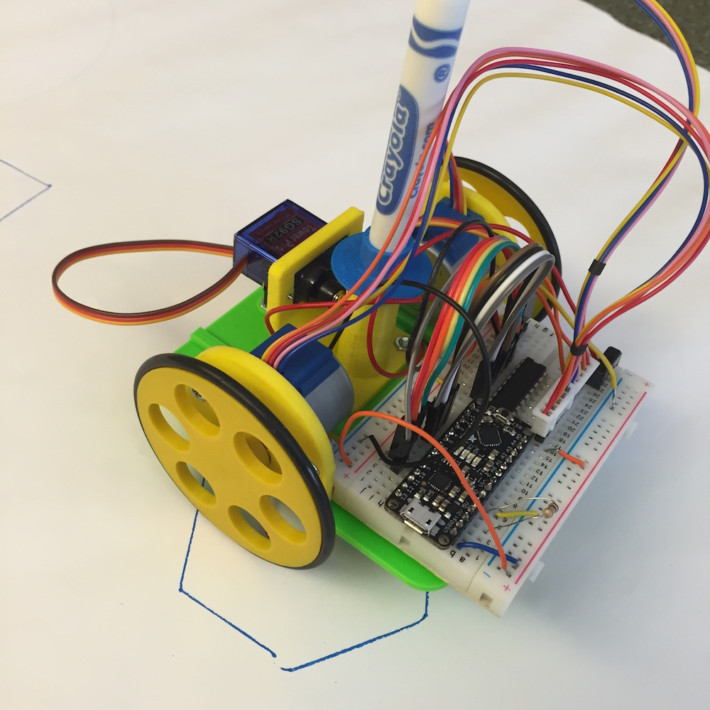
The original turtles were robots which could draw on a real piece of paper...
…but we are just using a simulated turtle!
A turtle is like a little robot. It can move around and draw lines.
The most common commands for the Python turtle are shown below:
t = Turtle() | This creates a turtle and stores it as “t”.
t.forward(10) | Move the turtle forward 10 pixels.
t.right(90) | Turn the turtle clockwise 90⁰
t.left(90) | Turn the turtle anticlockwise 90⁰

A first turtle program:
Go to the webpage: https://lc8325635.github.io/lc/lessons/programming/python/turtle-intro/index.html
Enter this program:
Using algebra saves us writing the same numbers over and over.
It also makes it easier to change the program later.
s = 100
a = 120

t = Turtle()
t.forward(s)
t.left(a)
t.forward(s)
t.left(a)
t.forward(s)
t.left(a)

Don’t forget you need to create a turtle before you can use it.

- What shape does this program draw?

- What would happen if we changed the value of s to s = 200?

- What would happen if we changed the value of a to a = 90?

- Using what you have learned, make a program which draws a square.

Python loops and turtle tessellations

Python can repeat the same commands multiple times using a for loop.

Enter this program:
The number in the brackets tells Python how many times to repeat.
t = Turtle()

for count in range(8):
t.forward(50)
t.left(45)

The commands which you want to repeat must be spaced in from the left-hand margin.

When you run the program, you should see a staircase as shown in pattern 1 below.

Using what you have learned, write programs to draw the other patterns shown.

Pattern 1: Staircase | Pattern 2: Crenels
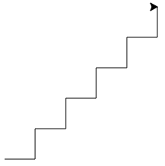 | 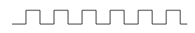
Pattern 3: Sawtooth | Pattern 4: Boxes
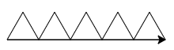 | 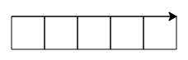
Pattern 5: Hexagon | Pattern 6: Grid
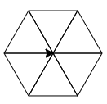 | 